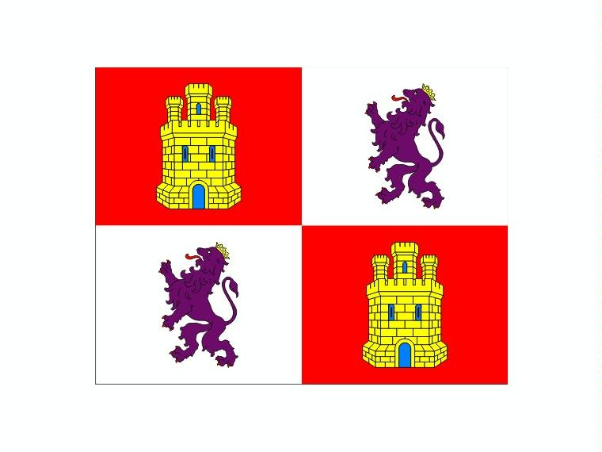

Hello we are from Spain.
my autonumus comunity is called Castile and leon.
And it five provincie the capital is valladolid the municipaliti hare i live called palencia in my autonumus comuniti live speek one leguage

